**Plantar Pressures Data Collection**

**Synchronizing Novel emed XL and Vicon Motion Capture**

*\*\*\* When finished, please put everything back to the way it was when you found it\*\*\**

Set Up

**Vicon**  
Needs to have been properly warmed up and calibrated.

Configuration = MainLabSyncNovel

Data is collected in: D > Raw Data > NovelSync

Labeling skeleton = LowerbodyClusterMultiSegFoot

*note: no model used, no cal trial needed, but take one anyway just in case

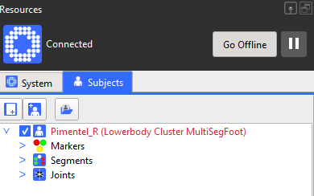

Data capture is at 100Hz

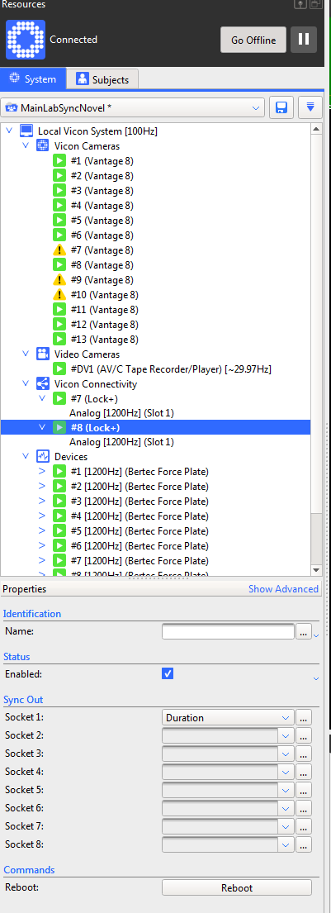

**Cables**

Switch the cable in the back of the middle black box from ‘Remote Start’ to ‘1’ in Sync Outputs

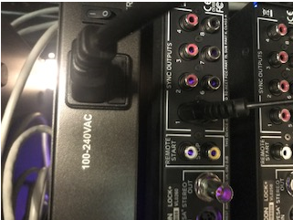

Check the cables below the video station, and make sure that the ACTIVE cable is connected.

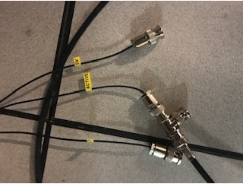

**In Novel:**

Open patient file per standard protocol.

Then, go to

Options > port settings > configure devices

In the pop up (first screenshot) select ‘NovelSync’ under hardware & select the plantar pressure mat, ensuring that the pop up matches the second screenshot below.

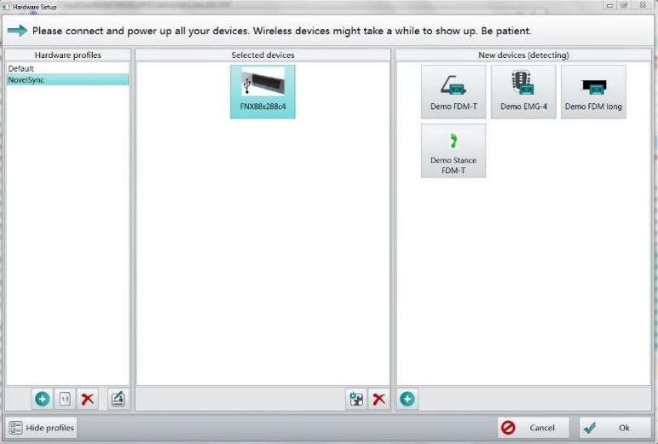

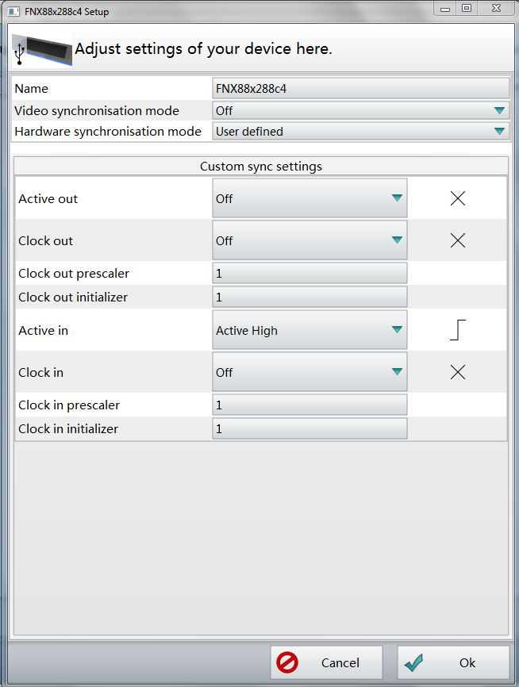

Data Collection

Place foot markers. See list at end of document for picture and list of marker placements.

Capture 10 trials over the force platforms and PP mat.

We are looking for: a minimum of two full consecutive steps over the PP mat for multiple trials

Clean foot strikes on force platforms (1 left and 1 right per trial, ideally)

If this is not happening, have the participant change their start location.

Data Transfer

First, export Ascii Files by following the instructions below.

Double click on the trials you want.

Then click “Analysis”

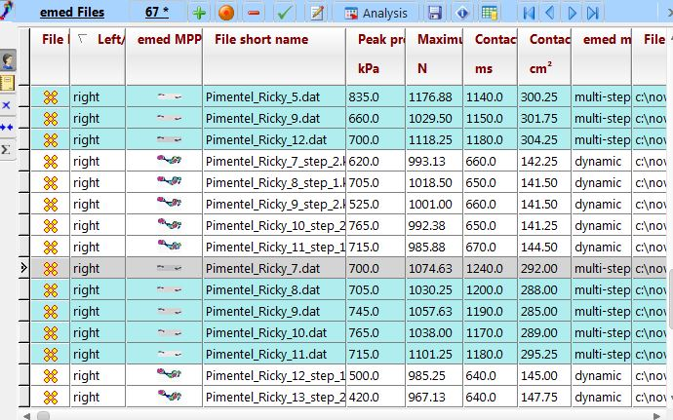

Click emascii.

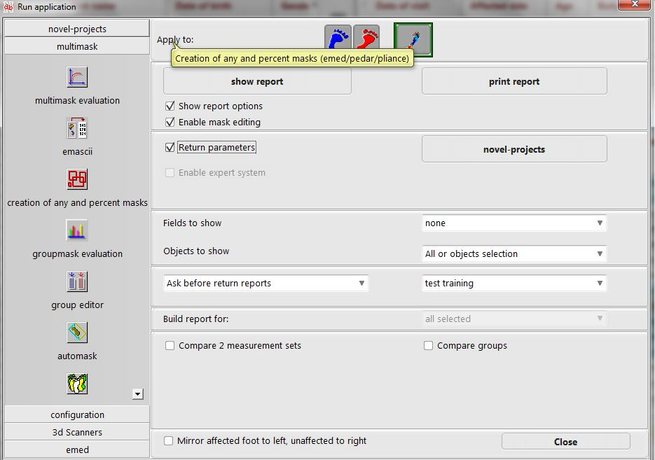

The window below (showing each trial) will pop up, select File > Save All > Ok and route to your desired save location (often C:\novel\novfile\ascii\asciiout)

The program may stop responding, but it’s okay. Give it a few minutes.

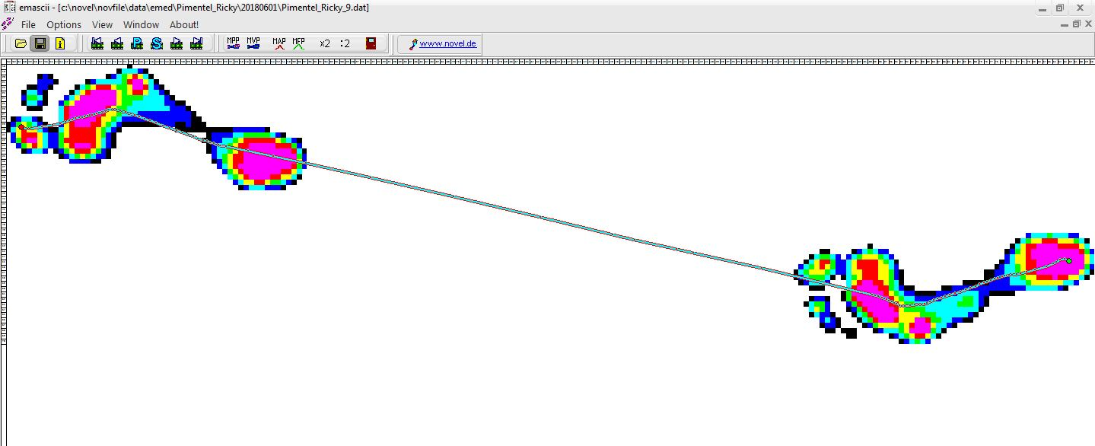

Move MoCap Files To 🡪 S:\cgma_ResearchMoCap\Projects\NovelSyncValidation

Move Ascii files

from 🡪 C:\novel\novfile\ascii\asciiout

to 🡪 S:\cgma_ResearchMoCap\Projects\NovelSyncValidation

Data Processing

Label and gap fill in Vicon.

Then, run the c3d and ascii files through the Impressions MATLAB code.

**Marker Placement.** For your convenience, here are some photos of the marker set up, and a list of all markers on the left side.

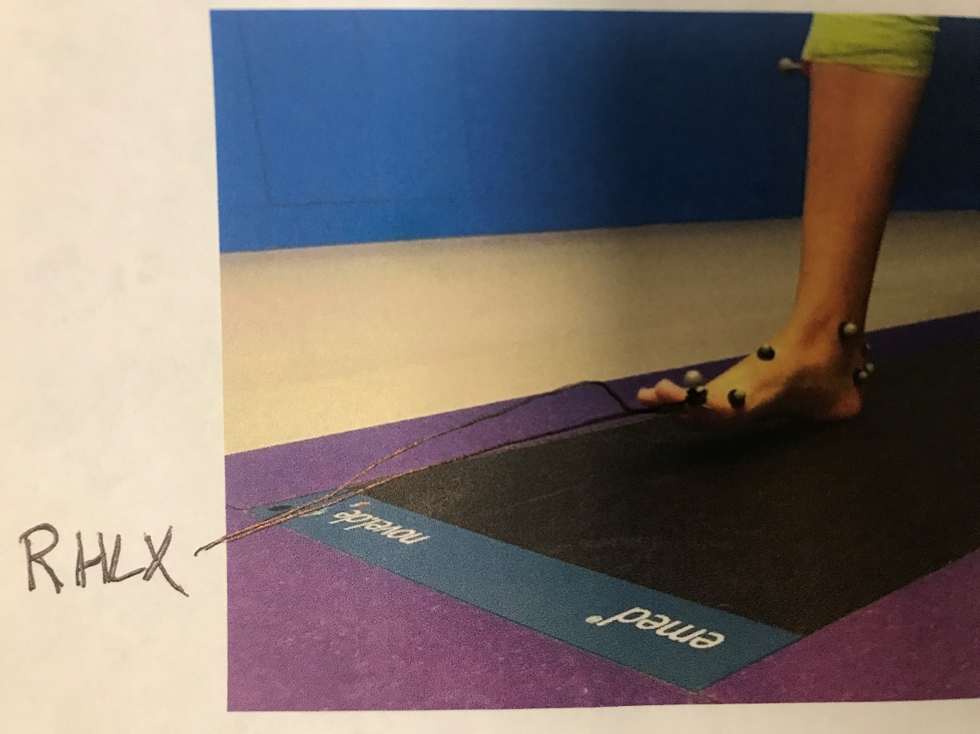

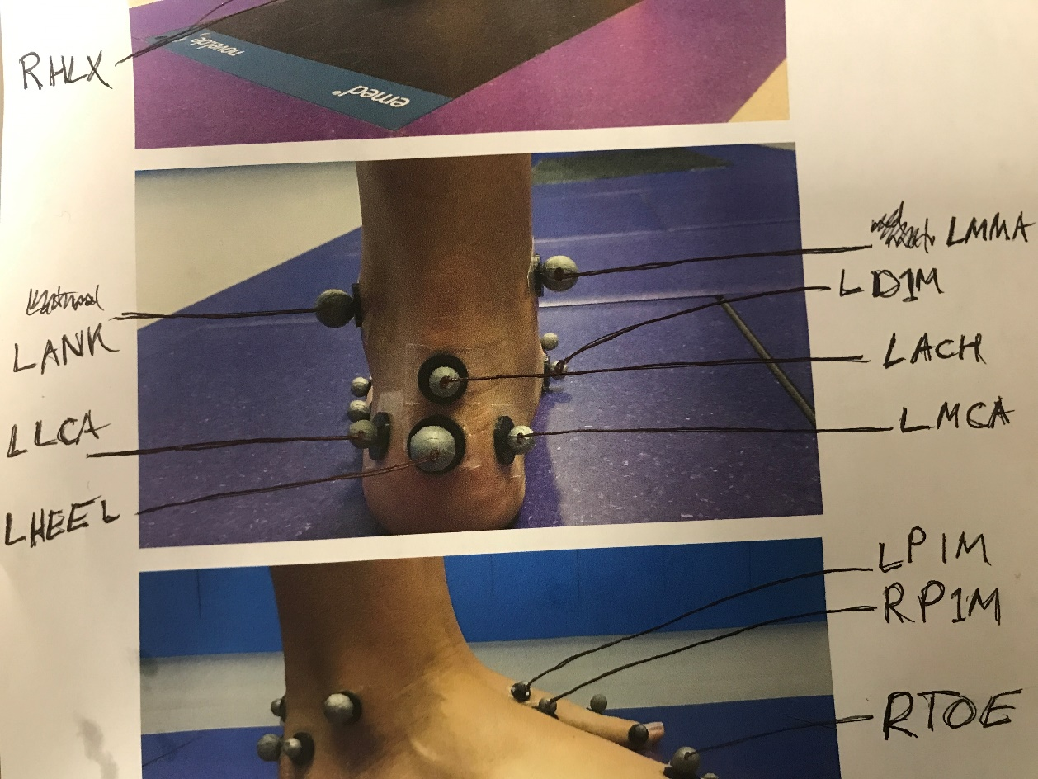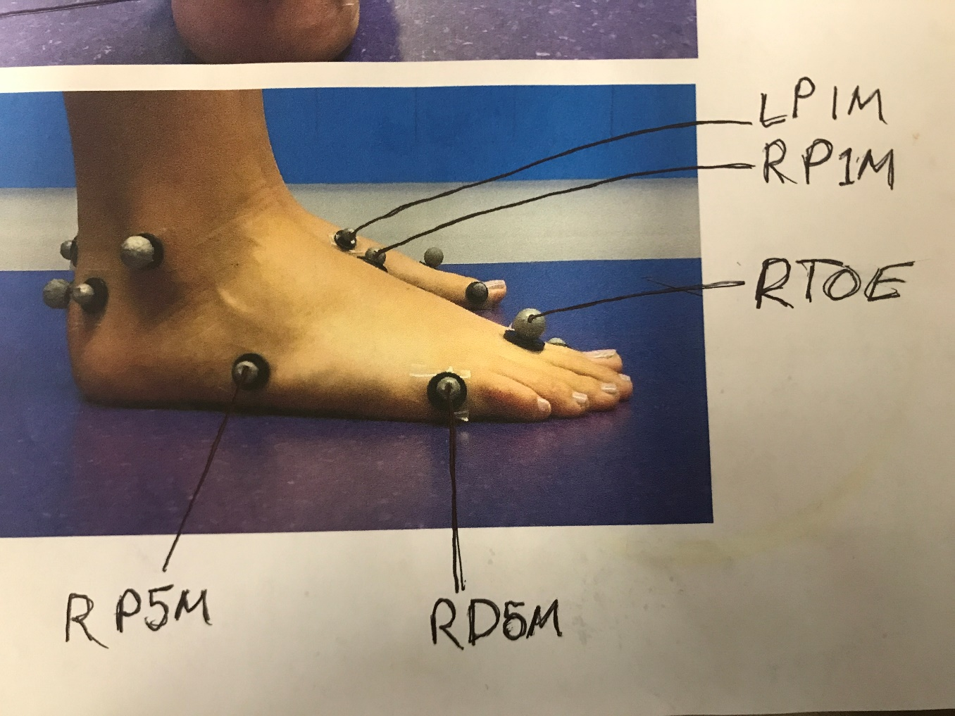

The set up for the right side is identical, except the first ‘L’ is a ‘R’. The markers written in green are mandatory, the markers in black optional. The black markers are listed because they are in in the labeling skeleton.

|  |  |
| --- | --- |
| Marker Name | Marker Location |
| SACR  SCRL  SCRR  L/RASI  L/RTHI  L/RTHIA  L/RTHIP  L/RKNEE  L/RMED  L/RFIB  L/RTUB  L/RTIB  L/RTIBA  L/RTIBP  L/RANK  L/RMMA  L/RHEEL  L/RLCA  L/RMCA  L/RTOE  L/RD1M  L/RD5M  L/RP1M  L/RP5M  L/RACH  L/RHLX | Sacrum. Not placed bilaterally.  Left PSIS  Right PSIS  Anterior superior iliac spine  Thigh (serves as wand), cluster  Anterior thigh, cluster  Posterior thigh, cluster  Lateral knee, on the lateral epicondyle  Medial knee, on the medial epicondyle  Head of the Fibula  Tibial tuberosity  Tibia (serves as wand), cluster  Anterior tibia, cluster  Posterior tibia, cluster  Lateral Ankle, on the lateral malleolus  Medial Ankle, on the medial malleolus  Heel – placed even with TOE when standing flat footed  Lateral calcaneus – even with HEE, placed 1 base width lateral  Medial calcaneus – even with HEE, placed 1 base width medial  Base of the 2nd toe on the left side  Distal head of the 1st met (big toe)  Distal head of the 5th met (pinkey toe)  Proximal head of the 1st met  Proximal head of the 5th met  Achilles, one base width above the heel  Hallux (big toe). Proximally and medially. |